**Translator, dictionary and player in one easy program**

FOR THOSE WHO STUDY A FOREIGN LANGUAGE

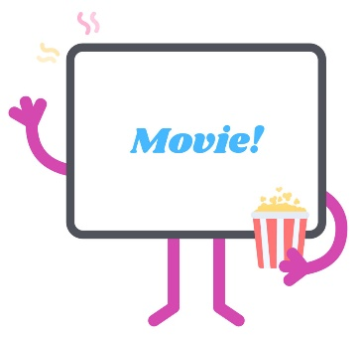

EasyLang is the free program also for watching movies with subtitles.   
Now it is very easy to follow the movie. The film can be watched on the steps of-phrase from the subtitles. You can easily repeat some phrases to gain a better understanding. An interesting movie with a native speaker is one of the best ways of learning a foreign language. You will hear the real language and not typical educational material. The plot of the film will help you to learn and remember new words effectively and easily. Later it will become much easier to repeat these words while watching a movie.

**Features**

* Translator, dictionaries and player are in one easy program
* It supports all popular languages
* You can call in one click several favourite dictionaries
* One history for all dictionaries
* Help in searching for subtitles
* Easy navigation throughout the subtitles
* Creation lessons according to the plot of the film
* The ability to save words for later replay
* Scan and highlighting for a word repeats*
* Assessment of a minimum vocabulary of the film*
* Idiom highlighting (only for English) *
* You cannot just watch movies, but also just to read foreign texts

**Language services**

Even if you do not know the language in which you are going to watch the film, you will not have to leave the program. Google and Microsoft language services are already embedded in the program. You can watch either lesson movie from start to finish without switching to another programs such as dictionaries or translators.

As you know, the best way to learn a foreign language is a natural linguistic environment, where the language is produced and used naturally. Unfortunately, many of us can’t afford to travel very often or to stay in any country for a long time. However, movies give you this great possibility to immerse yourself in this environment and to feel a real language. Even if you are all beat up, watching an interesting film is always pleasant pastime. You will spend more time both on your studies and on the things you like to do.

So… sit on the couch, take your laptop watching your favorite movies and enjoy the learning process!